SIMATS ENGINEERING
Department of Computer Science and Engineering
ASSESSMENT TOOL 2 – RAG-BASED MINI ASSIGNMENT (DOCUMENT QA / AI AGENT DEMO)
Experiment: Laboratory SOP RAG Assistant
1. Aim
To develop a Retrieval-Augmented Generation (RAG) based Laboratory SOP Assistant that retrieves relevant information from laboratory safety documents using semantic search and generates grounded answers using the Gemini API.
2. Problem Statement
Laboratory safety procedures are often distributed across multiple SOP and safety documents. Finding the correct procedure manually can be time-consuming and may lead to incorrect interpretation.
The proposed system uses RAG to retrieve the most relevant sections from laboratory SOP documents and uses Gemini to generate answers based only on the retrieved information, while providing the corresponding source documents and page numbers.
3. Objectives
- Load multiple laboratory SOP PDF documents.
- Extract text from the PDFs.
- Divide the extracted text into manageable chunks.
- Generate vector embeddings using all-MiniLM-L6-v2.
- Store the embeddings in ChromaDB.
- Retrieve relevant SOP sections for a user query.
- Generate grounded answers using Gemini.
- Display the source PDF and page number.
- Avoid generating answers when sufficient SOP evidence is unavailable.
4. Software and Technologies
Component | Technology
Programming Language | Python
PDF extraction | pypdf
Embedding model | all-MiniLM-L6-v2
Vector database | ChromaDB
LLM | Gemini
Environment variables | python-dotenv
IDE | Visual Studio Code

5. Input Documents
The system uses three laboratory safety documents:
CCNY Laboratory Chemical Spill Guide.pdf
CHEM-SWP-001-Acidic_Basic-Spill-Clean-Up.pdf
IIScSafetyManual_Ver1_01.pdf

6. RAG Architecture

7. Implementation Results
Your actual results are:
PDF files found: 3
Pages loaded: 78
Total chunks created: 255
Embeddings generated successfully
Embedding dimension: 384
Documents in ChromaDB: 255
Therefore:
3 PDFs → 78 pages → 255 chunks → 255 embeddings → ChromaDB

8. Test Case — Acid Spill
Query
What should I do if acid spills in the laboratory?
Retrieved source
CCNY Laboratory Chemical Spill Guide.pdf
Page: 5
The system retrieved information concerning:
- Acid spill emergency thresholds
- Evacuation
- PPE
- SDS consultation
- Spill containment
- pH checking

Result
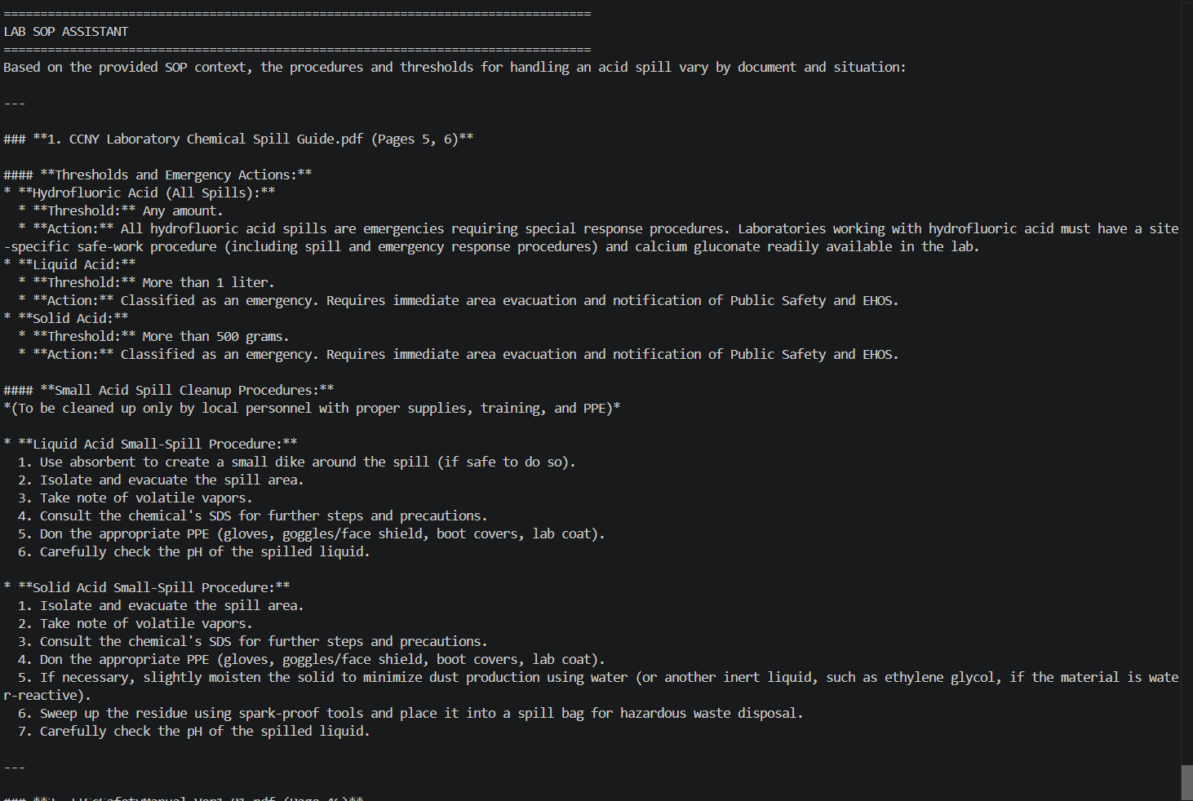

9. Test Case — Cryogenic Liquids
Query
What equipment is used for handling cryogenic liquids?
Retrieved source
IIScSafetyManual_Ver1_01.pdf
Pages: 35, 36, 38, 56
The system identified:
- Cryo-rated gloves
- Face shields
- Aprons
- Rated dewars/flasks
- Liquid cylinders
- Safety valves
- Rupture disks
Result
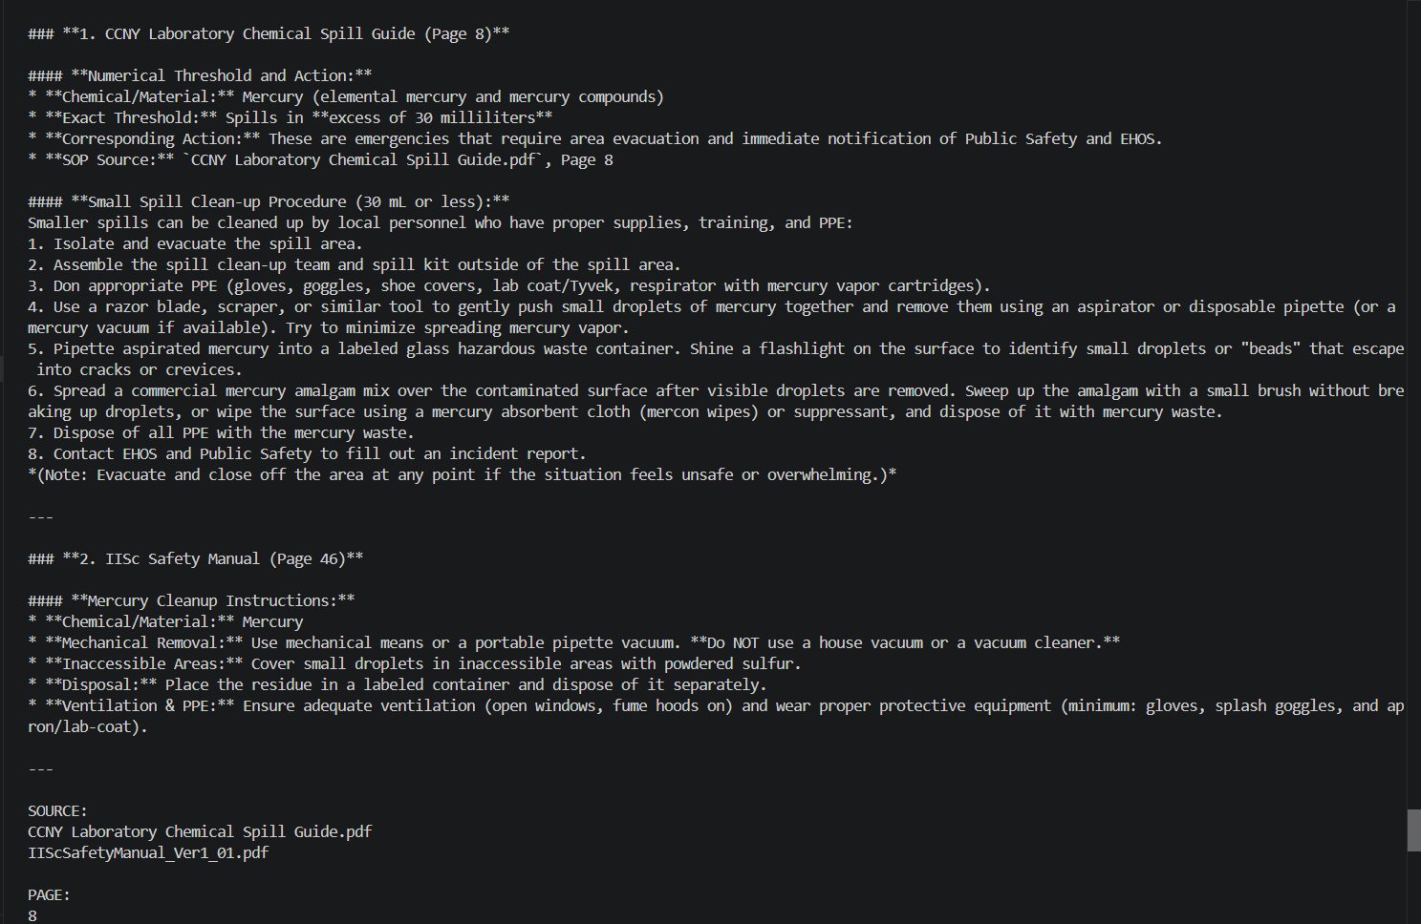
10. Test Case — Emergency Spill
Query
When should a laboratory spill be treated as an emergency?
The system retrieved relevant sections from:
CHEM-SWP-001-Acidic_Basic-Spill-Clean-Up.pdf
IIScSafetyManual_Ver1_01.pdf
CCNY Laboratory Chemical Spill Guide.pdf
The generated answer distinguished the conditions by SOP source instead of treating all thresholds as one universal rule.
Result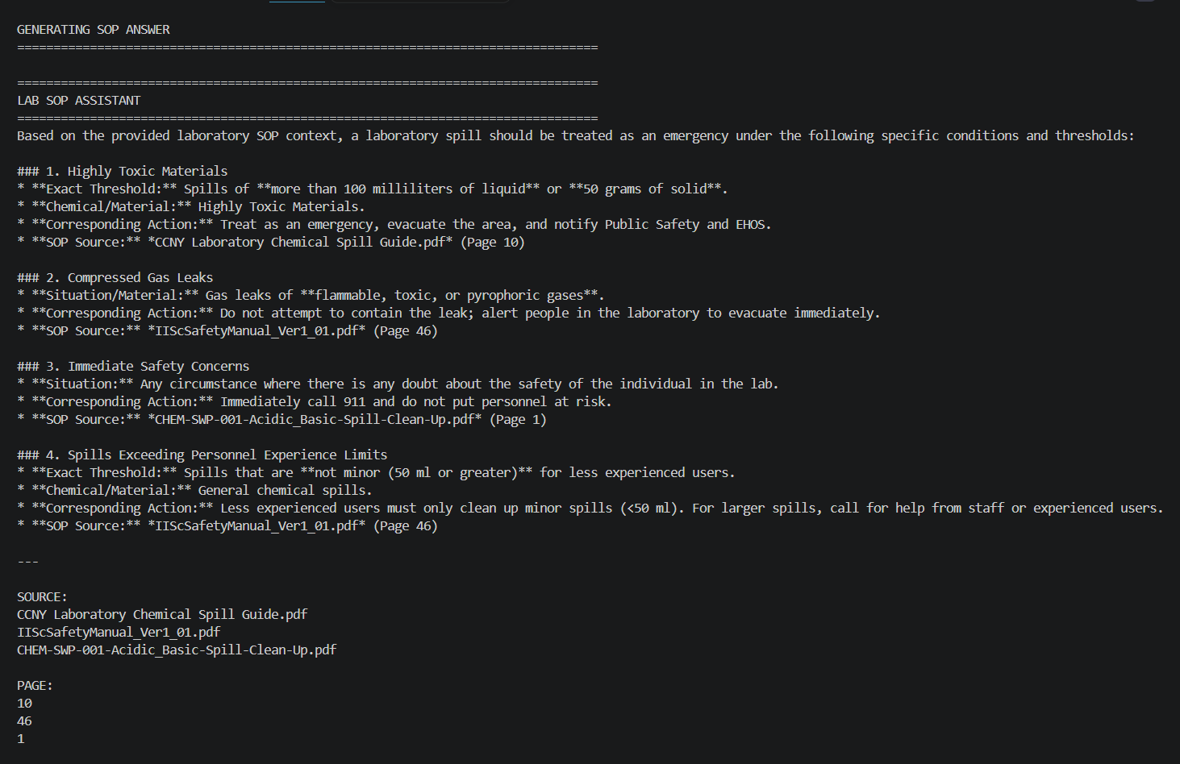

11. Test Case — Unsupported Question
Use:
What is the boiling point of water?
Expected behavior:
The available SOP documents do not provide enough
relevant information to answer this safely.
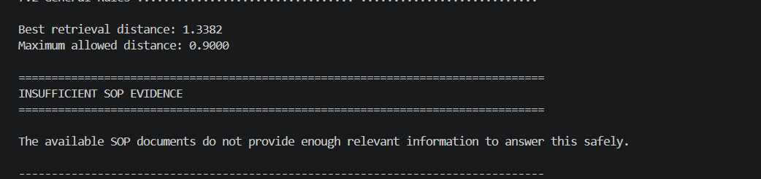
This demonstrates grounding and helps prevent the LLM from answering questions outside the SOP knowledge base.
12. Advantages
- Fast information retrieval from multiple SOP documents.
- Semantic search rather than simple keyword matching.
- Answers are grounded in retrieved SOP content.
- Provides source and page references.
- Can handle different laboratory safety topics.
- Reduces unsupported LLM responses.
- New SOP documents can be indexed when the database is rebuilt.

13. Limitations
- The quality of the answer depends on the quality of PDF text extraction.
- OCR may be required for scanned PDFs.
- Retrieval thresholds may require tuning.
- The system should not replace official laboratory safety procedures or trained safety personnel.
- Gemini responses depend on the retrieved context.

14. Conclusion
The Laboratory SOP RAG Assistant successfully combines semantic retrieval and generative AI to provide grounded answers from laboratory safety documents.
The system processed 3 PDF documents containing 78 pages, generated 255 text chunks, converted them into 384-dimensional embeddings, and stored them in ChromaDB. Relevant SOP sections were successfully retrieved for queries involving acid spills, emergency conditions, and cryogenic-liquid handling.
The project demonstrates how Retrieval-Augmented Generation can improve access to domain-specific laboratory safety information while maintaining source traceability.

